Setting up user in git :

$ git config --global user.name “Tandel, Mangesh”

$ git config --global user.email [mangeshtandel@gmai.com](mailto:mangeshtandel@gmai.com)

$ git config --list

Create first project in GIt

$ pwd

C:\user\mangesh\

Current working directory

$ ls

Desktop/

Documents

* Initialize directory

$ git init

Initialized empty Git repo in c:\users\mangesht\

First commit in GIT

$ git status

Make file using notepad

Example.txt

$ git status

On branch master

Untracked files

Example.txt

$git add Example.txt

$ git status

No commit yet

$ git commit –m “My first Git commit”

{master]

1 file change, 1 insertion

$ git status

Edit example.txt again

$ git status

Modified: Example.txt

$ git add .

$ git status

$ git commit –m “Second commit”

$ git status

**Add files and commit log in GIT**

Copy and paste example.txt

Add 2 file exampl1.txt and example2.txt

$ git status

Untracked files :

$ git log

Second commit

My first git commit

$ git log --author=”Tandel, Mangesh”

381 git log

382 git reset d47fbcd9bbcaf1e2a77e25d558a8ff350147a4ad

383 ls

384 git status

385 git revert "d47fbcd9bbcaf1e2a77e25d558a8ff350147a4ad"

386 ls

387 git status

388 cat example.txt

389 git log --oneline

390 ls

391 pwd

392 ls -ltr

393 git revert HEAD

394 ls -ltr

Second commit

My first git commit

$ git status

$ git add .

$ git status

$ git commit –m “New files from Mangesh”

$ git log

New files from Mangesh

Second commit

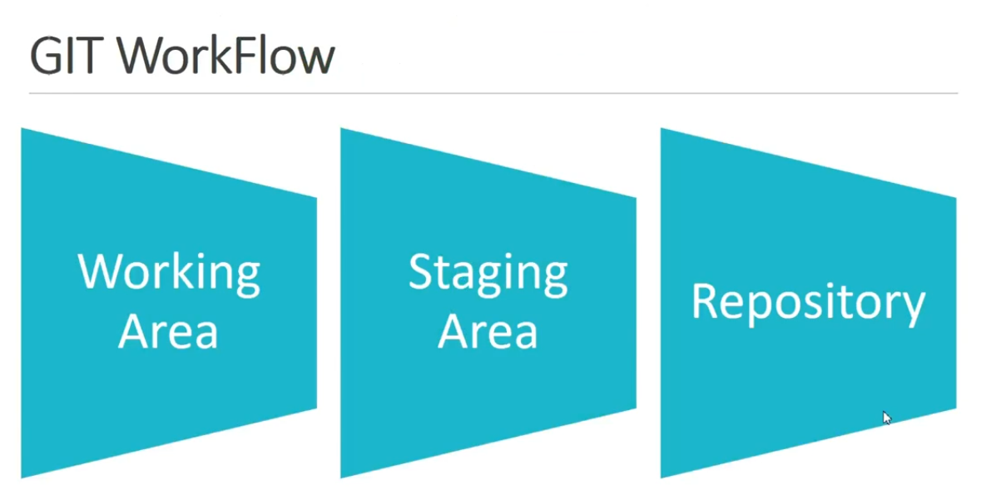

$ git status

Modify 2 files in folder

$ git status

Changes not staged for commit

$ git add Example2.txt

$ git status

Modified : Example2.txt

Open example2.txt and see changes

$ git status

$ git commit –m “Third commit”

Only modified changes saved

$ git status

Modified

Modified

**Text Editor in GIT**

Windows

Notepad++

Bash alias

MACOS  
textMate2

Linux

Sublime text

$ wget -qO - https://download.sublimetext.com/sublimehq-pub.gpg | sudo apt-key add –

$ echo "deb https://download.sublimetext.com/ apt/stable/" | sudo tee /etc/apt/sources.list.d/sublime-text.list

$ sudo apt-get update

$ sudo apt-get install sublime-text

$ git config --global core.editor "subl -n -w"

Now you add any text

$ git commit

$ git log

See changes in editor.

Install Notepad++

Browser >> notepad ++

Configure notepad++ with Git

* Open git bash
* $ notepad++ .bash_profile
* Create it yes/no
* Add new line
* Alias npp=’notepad++.exe –multiInst –nosession’
* Press ctrl+s, ctrl+w, ctr+nw
* Notepad++ .bash_profile
* Git config –global copy paste from ppt

$ cat ~/.gitconfig

$ git config ==global –e